Deliverable 4: TO-BE Technology Architecture
Company: Aegis Health Partners
The Technology Architecture defines the physical and infrastructural implementation of the application layer. This deliverable covers the cloud deployment model, the explicit technology stack, and an estimated operational cost analysis.
1. Deployment Architecture
To ensure high availability, HIPAA compliance, and scalable processing for the telehealth event streams, the solution is deployed via a Cloud-Native architecture on Amazon Web Services (AWS) using Kubernetes.
This diagram illustrates the cloud infrastructure, showing how the microservices are hosted in EKS and how the Polyglot databases are managed.

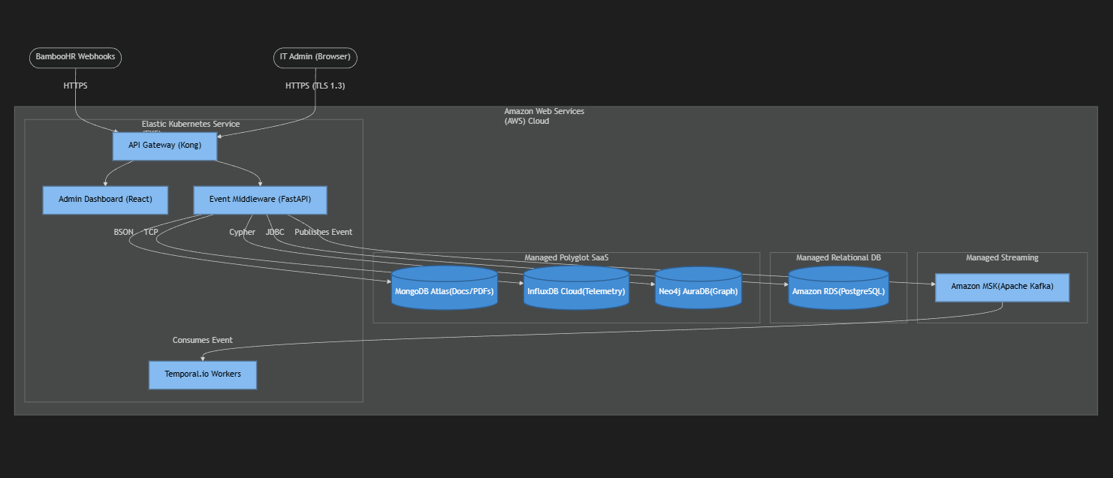

2. Technology Stack
The technology stack utilizes best-in-class, open-source-first tools to minimize vendor lock-in while maximizing developer velocity and system resilience.
A. Frontend & User Interface
- Framework: React 18 with Vite (Fast build times).
- Styling: TailwindCSS (Rapid, consistent UI development).
- Purpose: Provides a custom, unified "single pane of glass" for the IT Help Desk to view Snipe-IT inventory alongside AI predictive alerts.

B. Integration & Middleware (The "Brain")
- API Gateway: Kong API Gateway (Handles rate limiting, JWT authentication, and routing).
- Microservices: Python (FastAPI) and Node.js. Chosen for excellent data processing capabilities and vast library support for API integrations.
- Event Bus: Apache Kafka (Amazon MSK). Ensures no webhooks from HR are dropped, even during system spikes.
- Orchestration: Temporal.io. Manages stateful logistics (e.g., waiting 14 days for a doctor to ship a FedEx box back before triggering an alert).
C. Polyglot Data Layer
- Relational: PostgreSQL (Core Snipe-IT Database, System of Record).
- Document: MongoDB Atlas (Unstructured HIPAA documents, wipe certificates).
- Time-Series: InfluxDB Cloud (High-velocity MDM hardware telemetry).
- Graph: Neo4j (Mapping complex dependencies between doctors, telehealth kits, and network nodes).
D. DevOps & Infrastructure
- Containerization: Docker & Kubernetes (AWS EKS).
- Infrastructure as Code (IaC): HashiCorp Terraform (Ensures the cloud environment is reproducible and auditable).
- CI/CD: GitHub Actions (Automated testing and container deployment).
3. Cost Estimation & Business Value
Aegis Health Partners is shifting from a CapEx (Capital Expenditure) model of buying on-premise servers to an OpEx (Operational Expenditure) cloud model. Below is a conservative monthly estimate to support 1,200 employees and high-velocity telemetry processing.
Infrastructure Component | Technology | Estimated Monthly Cost
Compute Cluster | AWS EKS (3x Worker Nodes) | ~$350
Relational Database | Amazon RDS (PostgreSQL - Multi-AZ) | ~$180
Event Streaming | Amazon MSK (Managed Kafka) | ~$220
Polyglot DB SaaS | MongoDB, InfluxDB, Neo4j (Pro Tiers) | ~$250
Networking & Gateway | AWS Load Balancers, Egress Data, Kong | ~$150
ITAM Software License | Snipe-IT (Self-Hosted) | $0 (Open Source)
Total Estimated Cloud Run Cost | OpEx | ~$1,150 / month

Return on Investment (ROI) Justification
While the cloud infrastructure costs approximately $13,800 annually, the system directly addresses the AS-IS business problem: a 30% loss rate on $3,000 telehealth kits.
By automating the offboarding and logistics workflows via Temporal.io and Kafka, Aegis expects to recover an estimated $150,000 annually in previously lost hardware. This results in a massive net positive ROI, paying for the entire technology stack's operational costs over 10 times over within the first year, completely aside from the mitigated HIPAA compliance risks.

